Homework

Answer the questions by SQL.

1. List all the employees whose salaries are more than 3000.

SELECT * FROM EMP WHERE SAL > 3000;  


1. List all the employees whose names begin with “S”.

SELECT * FROM EMP WHERE ENAME LIKE 'S%'; 

1. List the employees whose name is “SMITH”, “ALLEN” or “FORD”.

SELECT * FROM EMP WHERE ENAME IN('SMITH','ALLEN','FORD');

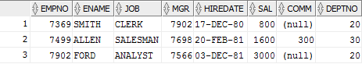

1. List all the employees whose department is “SALES”.

SELECT * FROM EMP a INNER JOIN DEPT b ON a.DEPTNO = b.DEPTNO WHERE b.DNAME = 'SALES';

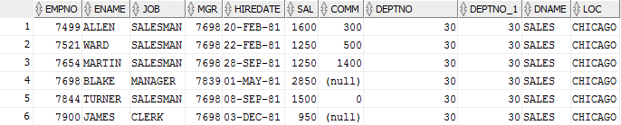

1. To get the value of average, biggest, smallest and total of each department, and order by department number.

SELECT dept.deptno, AVG(sal) AS AVERAGE, MAX(sal) AS MAXIMUM, MIN(sal) AS MINIMUM, SUM(sal) AS SUM FROM emp, dept WHERE emp.deptno = dept.deptno GROUP BY(dept.deptno) ORDER BY dept.deptno asc;

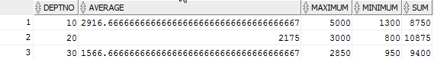

1. To get the total number of employees, whose salary is more than 3000 for each department.

SELECT COUNT (ENAME) AS NUMBER_OF_EMPLOYEE ,SAL, DEPTNO FROM EMP WHERE SAL >= 3000 GROUP BY DEPTNO ,SAL;



1. TO get the number of the average salary for each department, according to the department name in ascending order

SELECT DEPT.DNAME ,AVG(SAL) AS average_of_salary FROM EMP INNER JOIN DEPT ON EMP.DEPTNO = DEPT.DEPTNO GROUP BY DEPT.DNAME ORDER BY DEPT.DNAME ASC;

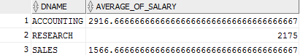

1. List the statistics of employees who have the same salary in each department, list their department number, salary, and number of employees.

SELECT d1.DNAME ,e1.SAL, COUNT(e1.ENAME) FROM EMP e1, EMP e2 , DEPT d1 WHERE e1.DEPTNO = d1.DEPTNO AND e1.SAL = e2.SAL AND e1.ENAME != e2.ENAME GROUP BY d1.DNAME,e1.SAL;



1. List the department with more than 2 employees in the same department, showing the name of the Department, the name of the area, and the number of the employees in the same department

SELECT d1.DNAME , d1.LOC , COUNT(e1.ENAME) as Count_of_Employee FROM DEPT d1 , EMP e1 WHERE d1.DEPTNO = e1.DEPTNO HAVING COUNT(e1.ENAME) > 2 GROUP BY d1.DNAME,d1.LOC;

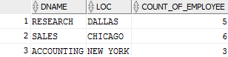

1. List the name and salary of employees whose salaries is higher than the average salary of the entire firm

SELECT ENAME , SAL FROM EMP WHERE SAL > (SELECT AVG(SAL) FROM EMP);

